Name: Jay Parekh Student ID: S14140141

CMP7228 Machine learning Assignment.
Tutor: Besher Alhalabi

Abstract.

The CRM department can sustain long-lasting connections with current clients by predicting client churn, and it also gives them a way to assess the churn risk of potential new clients. How can client churn be correctly predicted? and Which variables are important in influencing bank turnover were the problems that needed to be addressed through machine learning. Using a Random Forest technique, a bank churn dataset with imbalance was cleaned, examined, pre-processed, displayed, and sliced. The classifier model underwent evaluation and training. Total transaction count, total transaction value, and total revolving balance were the top three significant characteristics. RandomizedSearchCV was used to tune the hyperparameters. A Decision Tree method was put up against the model, and it performed worse overall. K means clustering was also implemented and was not successful due to a technical error in its compatibility.
Table of Contents
Abstract. 1
1. Introduction, aim and objectives 3
Introduction 3
Aim. 3
Objectives. 3
2. Dataset description. 4
3. Problem to be addressed. 9
4. Machine learning model 10
4.1. Summary of the approach 10
4.2. Collecting necessary tools. 11
4.3. Data collection. 12
4.4. Data Synthesis. 14
4.5. Inspection of data. 16
4.6. Feature extraction. 17
4.7. Data Visualization. 19
4.8. Feature selection. 24
4.9. K means clustering. 25
4.10 Random Forest. 27
Performance evaluation and model fitting. 27
Tuning of hyperparameters. 32
4.11. Decision Tree 35
Performance evaluation and model fitting. 35
Tuning of hyperparameters. 39
4.12. Findings and Discussion 41
5. Conclusion, Recommendations and Future Work 42
Conclusion. 42
Recommendations. 42
The bank should concentrate on keeping regular customers who frequently do sizable transactions, since they were discovered to be at the biggest risk of leaving. 42
Future work. 42
6. References 43

1. Introduction, aim and objectives

Introduction
When a client closes their bank account, a phenomenon known as bank client churn or client defection, the bank's ROI is reduced. (2022 Retention Idea) The percentage of customers who leave within a certain period of time is known as the churn rate. Lemmens et al. (2013) noted the significance of finding a method to precisely identify the behaviours of, and predict churning clients using machine learning techniques. Registering a new client costs banks five times as much as successful customer relationship management (CRM) would cost to retain clients.

Aim.
Using supervised and unsupervised learning techniques, predict client turnover while finding trends in the dataset that might have an impact on the outcome.

Objectives.
- Examine the dataset for correlations.
- Assess how well KMeans clustering, a Random Forest model and a Decision Tree model predict customer attrition.
- Compare the effectiveness of supervised learning against unsupervised learning.
- Determine the top 3 characteristics influencing customer turnover.

2. Dataset description.
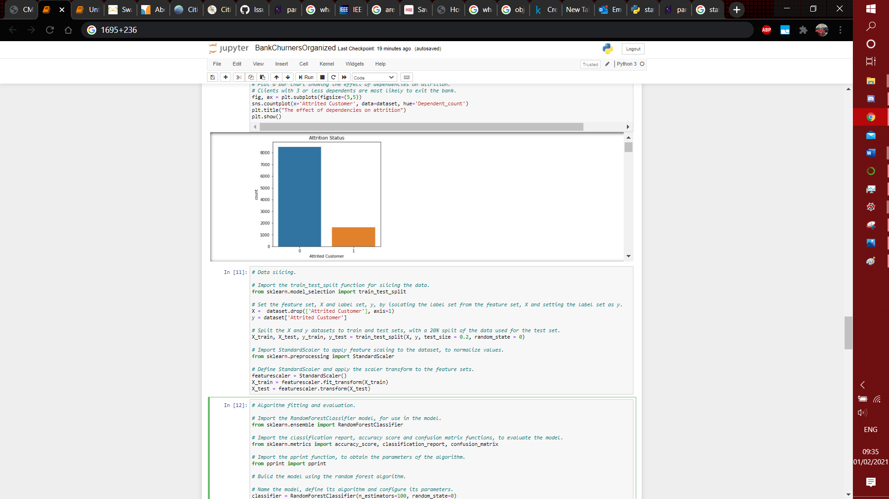
Image 1: Label distribution
The public domain dataset (Goyal, 2020), was last updated in December 2020 and was downloaded from the Kaggle website since it had a good usability grade (Goyal, 2020). It has 10127 rows and 23 columns with a 5.25:1 ratio of retained clients to lost clients, a significant bias seen in Image 1. Numerous bank churn datasets were discovered to have comparable characteristics, hence the chosen dataset was picked.
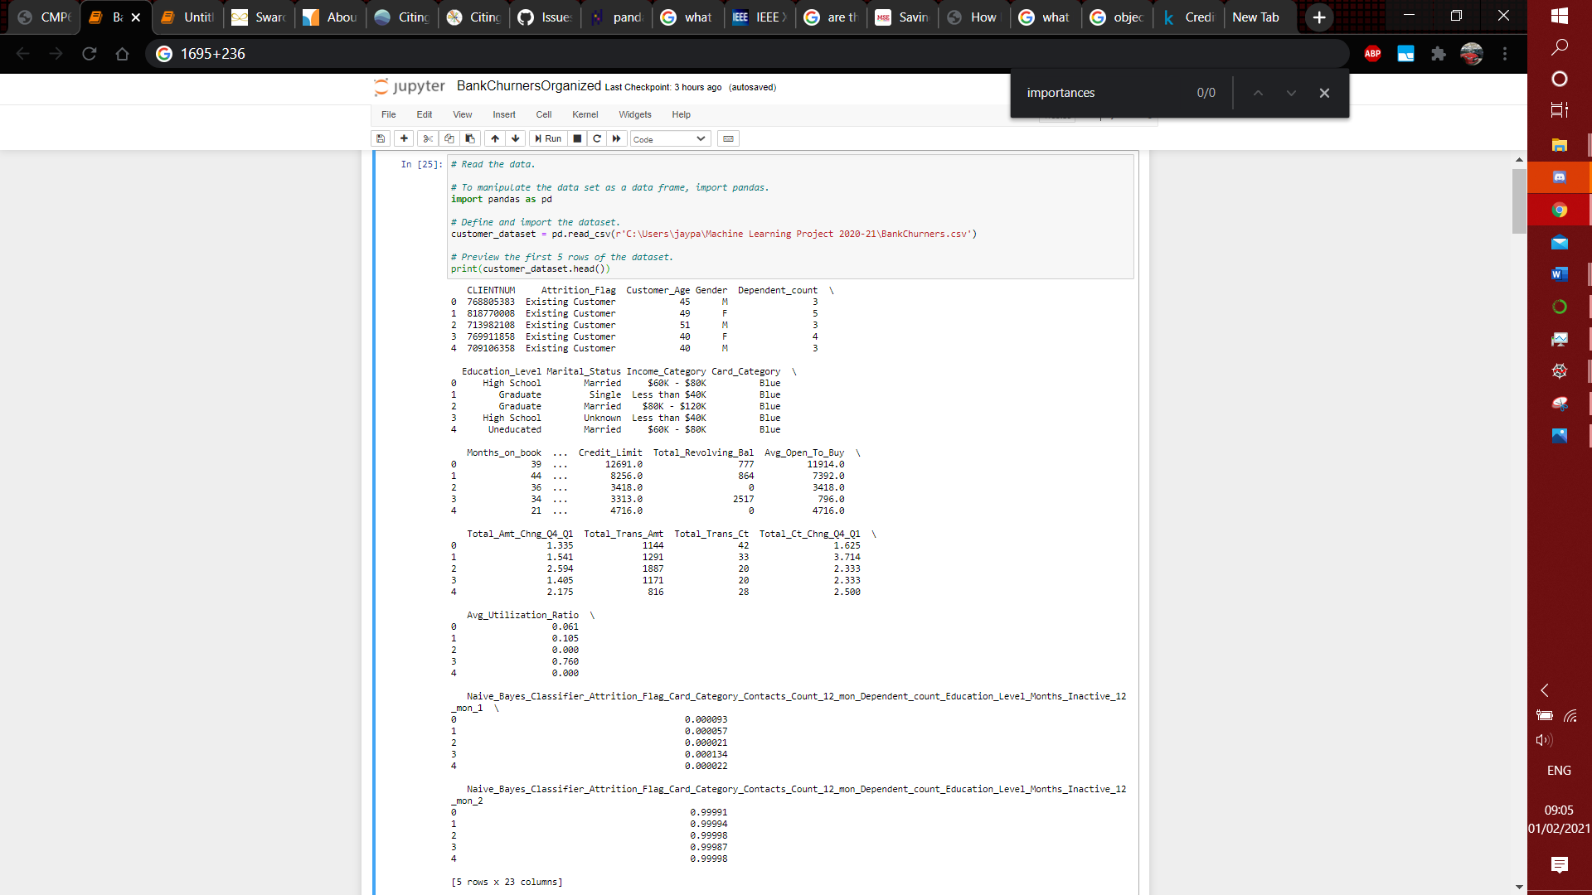
Image 2: Dataset preview.
Image 2 shows:
- The “dataset.head” function previewed the first 5 rows.
- The author's instructions for removing the final two columns had to be followed.
- After evaluating the dataset, it was decided to additionally eliminate the first column, which contained the client's account number.
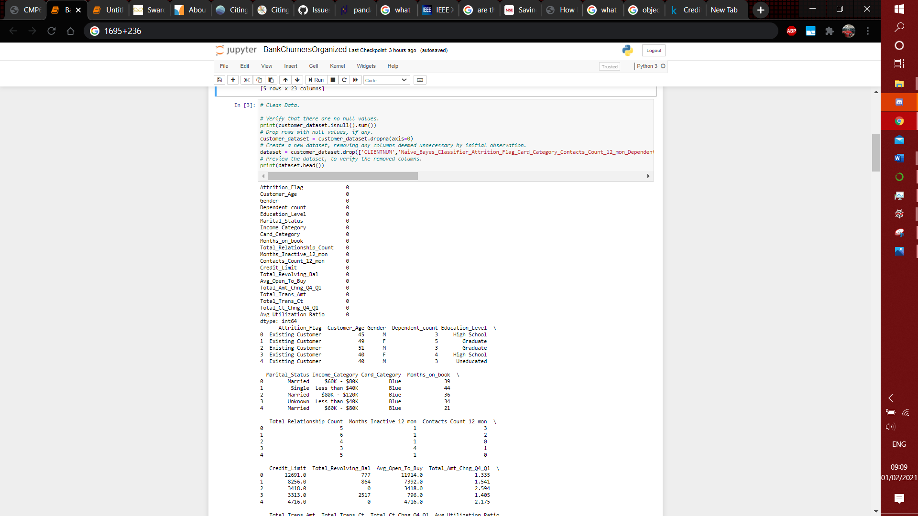
Image 3: NaN Values.
Image 3 shows a NAN value check, of which there were none.
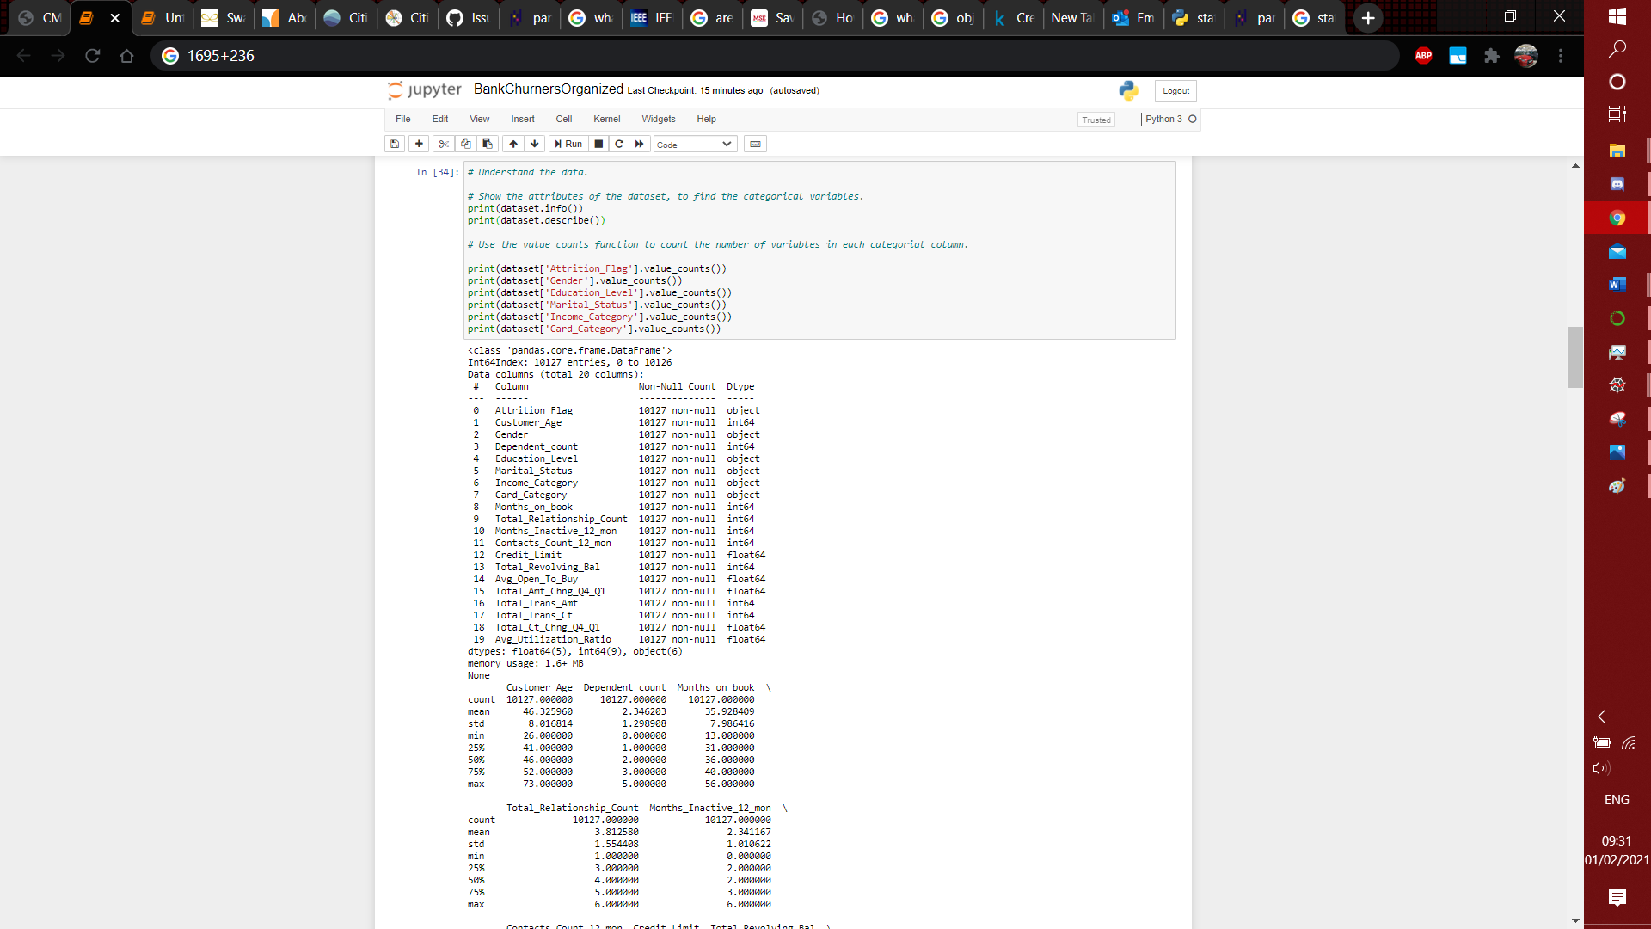
Image 4.1: Data semantics.

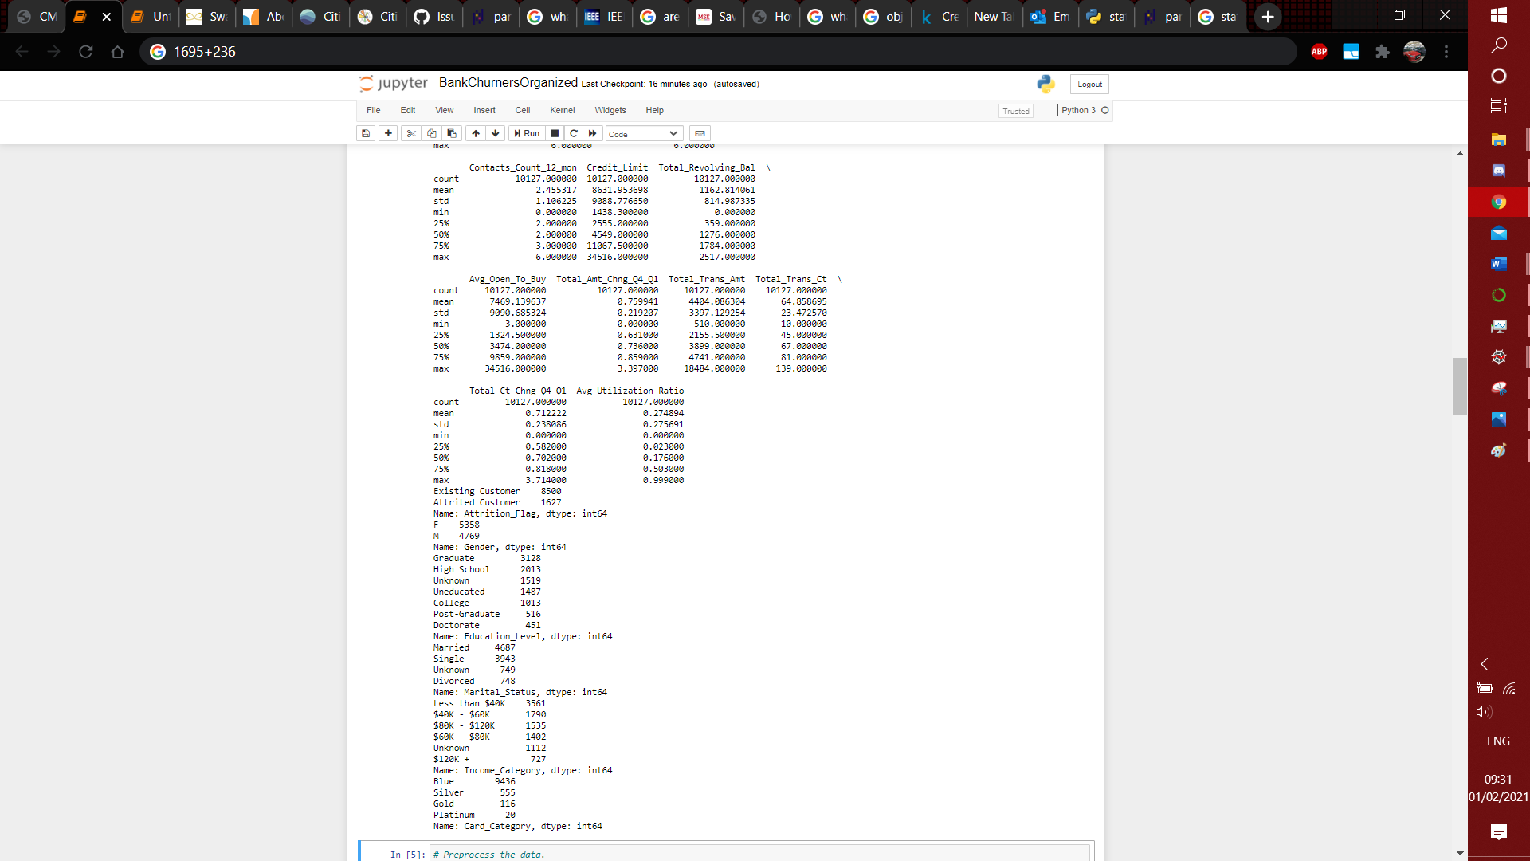
Image 4.2: Feature counts.
Image 4 illustrates how each category variable was discovered after the dataset was examined for variable types. Six category variables were present. Statistics did not reveal any irregularities.
To determine which qualities should be excluded from the prediction model, the relevance of the attributes is taken into account.
Features | Relevancy | DType | Correlation with churn.
CLIENTNUM | N | N/A | There will be no connection between the account number and client attrition.
Attrition_Flag | Y | Categorical | The labels for the machine learning model's prediction-generating machine learning model will be taken from the attrition flag column.
Customer_Age | Y | Numeric | Attrition would be more likely to occur with older clients.
Gender | Y | Categorical | To look into how gender affects attrition.
Dependent_count | Y | Numeric | Customers who have more dependents are more likely to depend on the bank.
Education_Level | Y | Categorical | To look into how attrition is impacted by the educational attainment of the client.
Marital_Status | Y | Categorical | Marital status must be taken into consideration because divorce is a significant factor in bank churn.
Income_Category | Y | Categorical | The bank's product selection could only be desirable to consumers in specific income brackets.
Card_Category | Y | Categorical | Customers with improved cards are more dependable, therefore attrition is less likely.
Months_on_book | Y | Numeric | Long-term client churn is less common than that of recent clients.
Total_Relationship_Count | Y | Numeric | Client attrition would be less probable if they had more ties with the bank.
Months_Inactive_12_mon | Y | Numeric | Since they don't need the bank's services, inactive users are more likely to be lost to attrition.
Contacts_Count_12_mon | Y | Numeric | As fewer problems arise, the attrition of clients who contact the bank less frequently may be less likely.
Credit_Limit | Y | Numeric | Low credit limit consumers are more likely to leave since they will seek for banks with greater credit limit.
Total_Revolving_Bal | Y | Numeric | High revolving balance consumers are less likely to leave because they are using the bank's services.
Avg_Open_To_Buy | Y | Numeric | Due to the client's assurance to the bank of a future purchase, the attrition of clients with a high average open to buy is less likely.
Total_Amt_Chng_Q4_Q1 | Y | Numeric | As they are taking money out of their account, customers with a negative ratio of change (1) are more likely to leave.
Total_Trans_Amt | Y | Numeric | Client attrition is less likely to occur when the overall value of their transactions is high.
Total_Trans_Ct | Y | Numeric | As a client's account is used more frequently, there is a reduced likelihood that they will leave.
Total_Ct_Chng_Q4_Q1 | Y | Numeric | Clients that have a negative ratio of change, less than one, are probable to leave since they are utilising their accounts less frequently.
Avg_Utilization_Ratio | Y | Numeric | Low average usage ratio consumers are more likely to attrition since they use their accounts less frequently.
Naive_Bayes_Classifier_Attrition…mon_1 | N | N/A | The creator of the dataset designated this column as being deleted.
Naive_Bayes_Classifier_Attrition…mon_2 | N | N/A | The creator of the dataset designated this column as being deleted.

Using ordinal encoding, certain attributes displayed an ordinal connection. The remaining properties implemented one hot encoding and used nominal relationships.

Feature type
Ordinal | Nominal
‘Education_Level‘ | ‘Attrition_Flag’
‘Income_Category’ | ‘Gender’
‘Card_Category’ | ‘Marital_Status’

3. Problem.
Predicting a customer's likelihood of churn based on their demographics and other information.
The RIPPER model accuracy was 88.3%, the valid recall was 79.9% (Fan Li et al., 2011). A study which used the CART model (Bhambri, 2020) showed an accuracy of 91.2% and recall of 61.2%. Recall score is for computational efficiency, accuracy is important for consistency.

4. Machine learning model

4.1. Summary of the approach
The shared model development strategy was taken into account during the development phases (Géron, 2019). The stages of model development are listed:
- Collecting necessary tools.
- Data collection.
- Data synthesis.
- Inspection of data.
- Visualisation of data.
- Feature extraction.
- Performance evaluation and model fitting.
- Tuning of hyperparameters.
- Findings and conclusions.

4.2. Collecting necessary tools.
The project directory was placed in a new folder, containing the new Jupyter notebook.
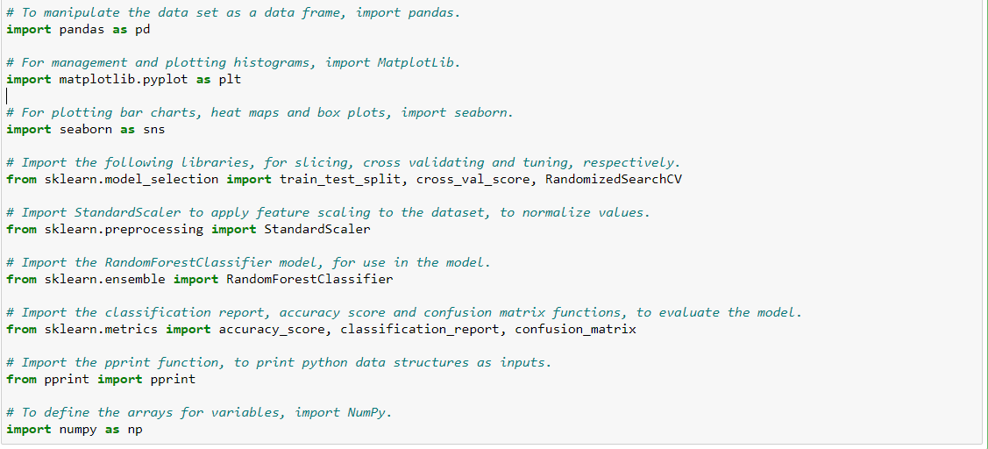
Image 5: Collecting necessary tools.
As seen in Image 5, the essential libraries and functions were imported into the notebook:
- Pandas, for manipulating data frames (pandas, 2022).
- Matplotlib, which may be used to organise plots and create histograms and box plots (Matplotlib, 2022).
- Seaborn, for creating heat maps and bar charts (Seaborn, 2022).
- The "train test split" function, which allows data to be divided (scikit-learn, 2022).
- The function "cross val score," which is used to cross-validate the model (scikit-learn, 2022).
- To randomly search for hyperparameters, use the "RandomizedSearchCV" function (scikit-learn, 2022).
- The "StandardScaler" function, which is used to scale the feature data normally (scikit-learn, 2022).
- The RandomForestClassifier algorithm, which will be applied to the model (scikit-learn, 2022).
- The functions "classification report," "accuracy score," and "confusion matrix," which assess the model's performance (scikit-learn, 2022).
- The "pprint" function, which prints Python data structures.
- NumPy, which creates arrays to specify various variables' intervals (NumPy, 2022).

4.3. Data collection.
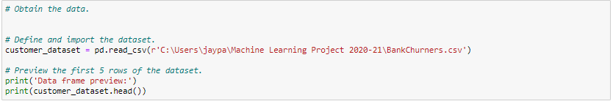
Image 6: Data loading.
Image 6 demonstrates the loading of a public domain Bank Churn dataset (Credit Card customers, 2020), consisting of 10127 rows and 23 columns.
- The dataset, which was named "customer dataset," was read using the "pd.read csv" method.
- To confirm the import, the dataset was shown using Python's ".head" function and printed using the "print" function.
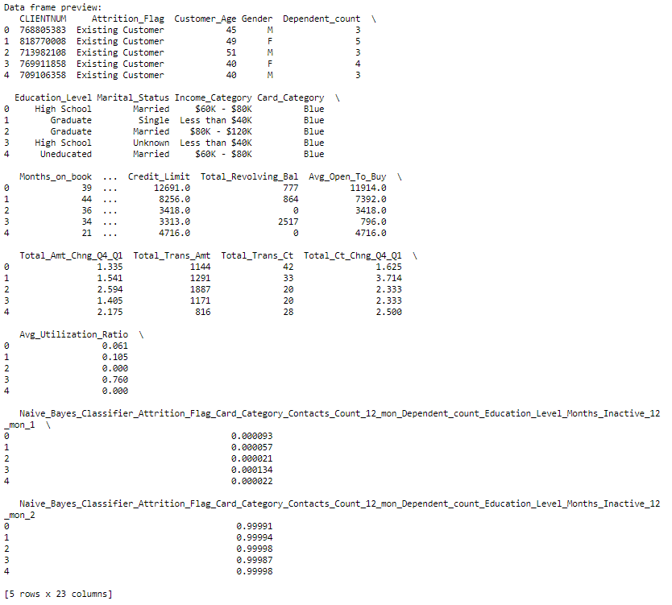
Image 7: Data preview.
Image 7 demonstrates that the script ran without a hitch and returned the requested data. When first looking at the output, three redundant columns were found: Two Naïve Bayes columns and the “CLIENTNUM” column.

4.4. Data synthesis.
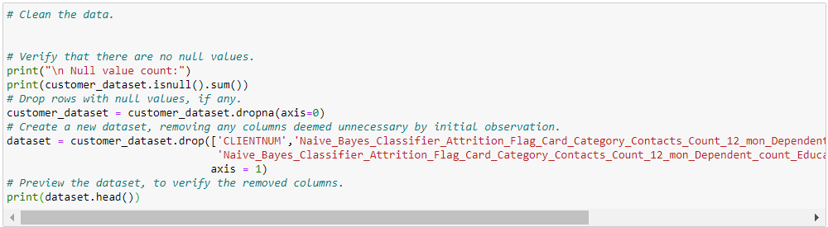
Image 8: Data synthesis.
According to Image 8:
- Any null values in the dataset were located and shown using the ".isnull.sum" method.
- If any null rows existed, they were deleted using the ".dropna" function, and the dataset was then rewritten.
- Columns that first observation judged unneeded were removed using the ".drop" method. The term "dataset" redefined the dataframe.
- The cleaned dataset was displayed using the ".head" function.

- 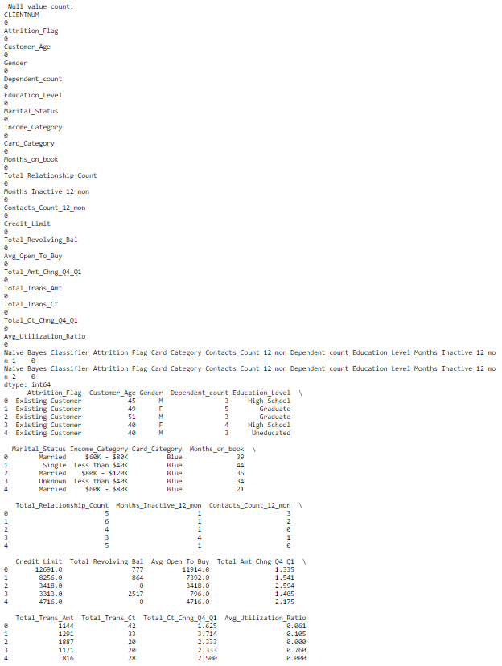
Image 9: Previewing synthesised data.
Image 9 demonstrates that the script ran flawlessly and returned the requested data. No rows were lost due to the absence of null values, as seen by the output. The preview demonstrates that the extra columns were correctly dropped.

4.5. Inspection of data.
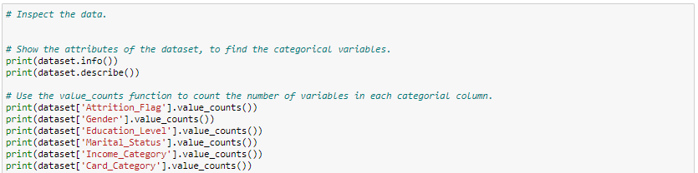
Image 10: Inspection of Data.
As demonstrated by Image 10:
- The variables’ attribute information was called using the “.info” function.
- The feature set was checked for abnormalities using the ".describe" function.
- The number of variables in each category were found using the “.value_counts” function.
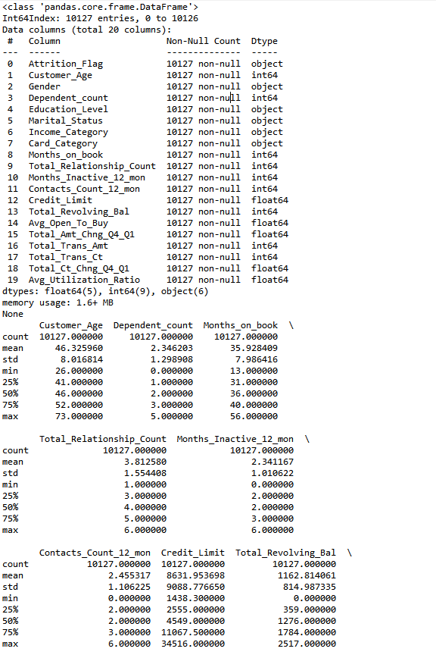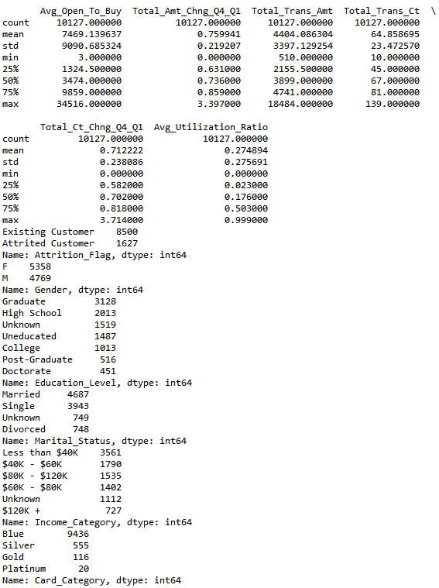
Image 11: Preview of inspection results.
Image 11 demonstrates that the script was successfully ran and returned the requested data. The result confirms that there are no significant abnormalities in the data and identifies the category columns, which are shown as "object." The categorical variables' counts and data types were successfully determined; "Attrition Flag," "Gender," and "Marital Status" were determined to be nominal variables, while the other variables were classified as ordinal variables.

4.6. Feature extraction.
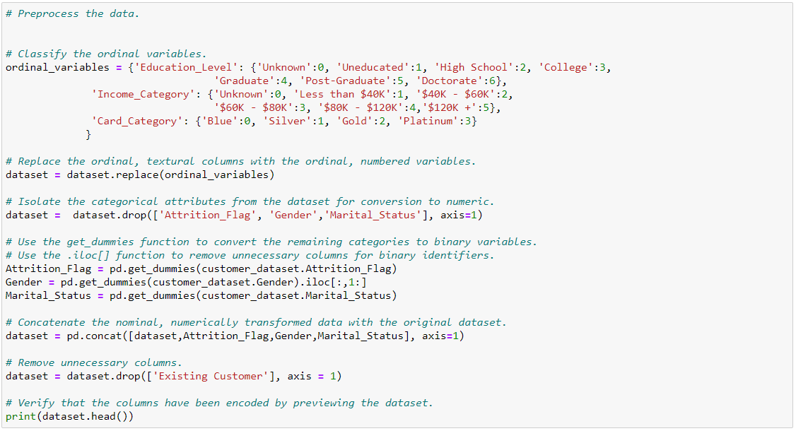
Image 12: Feature extraction.
As demonstrated by Image 12:
- The category text variables were indicated to be replaced with ordinal, numeric variables in a script named as "ordinal variables."
- The modifications were made to the dataset using the ".replace" method.
- The category text variables transformed into nominal variables were separated using the ".drop" function.
- The category text variables were transformed into columns using the ".get dummies" function, revealing each variable as a nominal, numeric value.
- The second column for gender was eliminated using the ".iloc" function because it is a binary identifier.
- The nominal, numerically modified values were concatenated with the original dataset using the ".concat" function.
- Of the two columns created by the label set, the superfluous one was removed using the ".drop" method.
- The newly modified dataset was displayed using the ".head" function.
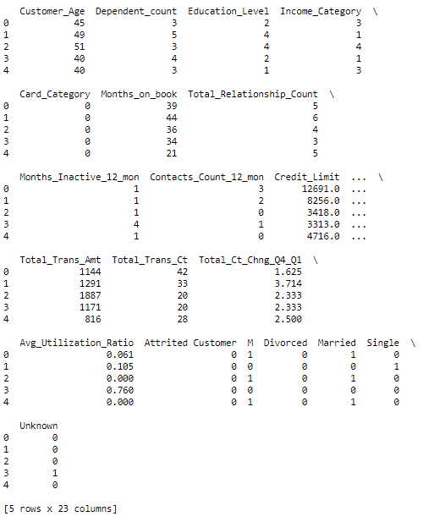
Image 13: Extracted features.
Image 13 demonstrates that the script was successfully ran, encoding the category variables and removing the extra columns.

4.7. Data visualization.
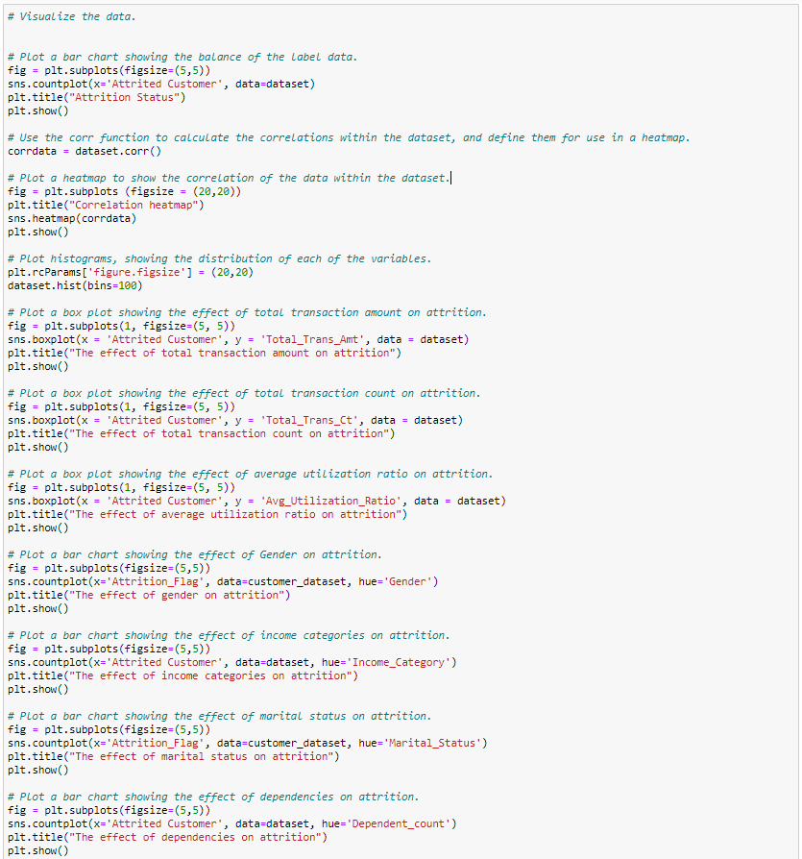
Image 14: Data visualisation techniques.
Image 14 demonstrates the methods used for plotting, resizing, labelling and previewing (not including histograms):
- Using the “.subplots” function, the dimensions of the Images were set, and the function was defined as “fig”, to unpack the tuple responsible for changing Image size (Géron, 2019).
- Using the “.title” function, the title of the plot was set.
- Using the “.show” function, the plot was set to display upon output.
- To size histograms, the “.rcParams” function was used to change the default Image size. Titles were automatically set.

To plot the correlation heatmap:
- The ".countplot" method was used to create the first plot. The label data from the dataset was used to create a bar chart that displays the label data's overall distribution.
- The correlations found with in data were produced as a table and designated as "corrdata" using the ".corr" function.
- The correlation data was shown as a heat map using the ".heatmap" function to visualise trends.
The data was shown with histograms using the ".hist" function. In order to get the appropriate distribution, 100 bins were used.
Total Transaction Amount, Total Transaction Count and Average Utilization Ratios were assessed using the ".boxplot" function, with the labels set on the x axis.
Gender, Income category, Martial Status and Dependency Count were assessed using the ".countplot" function, with the label data set as the x axis.
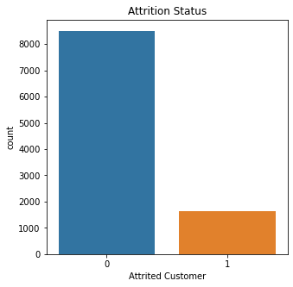
Image 15: Label distribution.
Image 15 shows there was 6 times more data for existing customers than attritted customers. A data imbalance was shown and could be improved by oversampling the data for attritted customers.
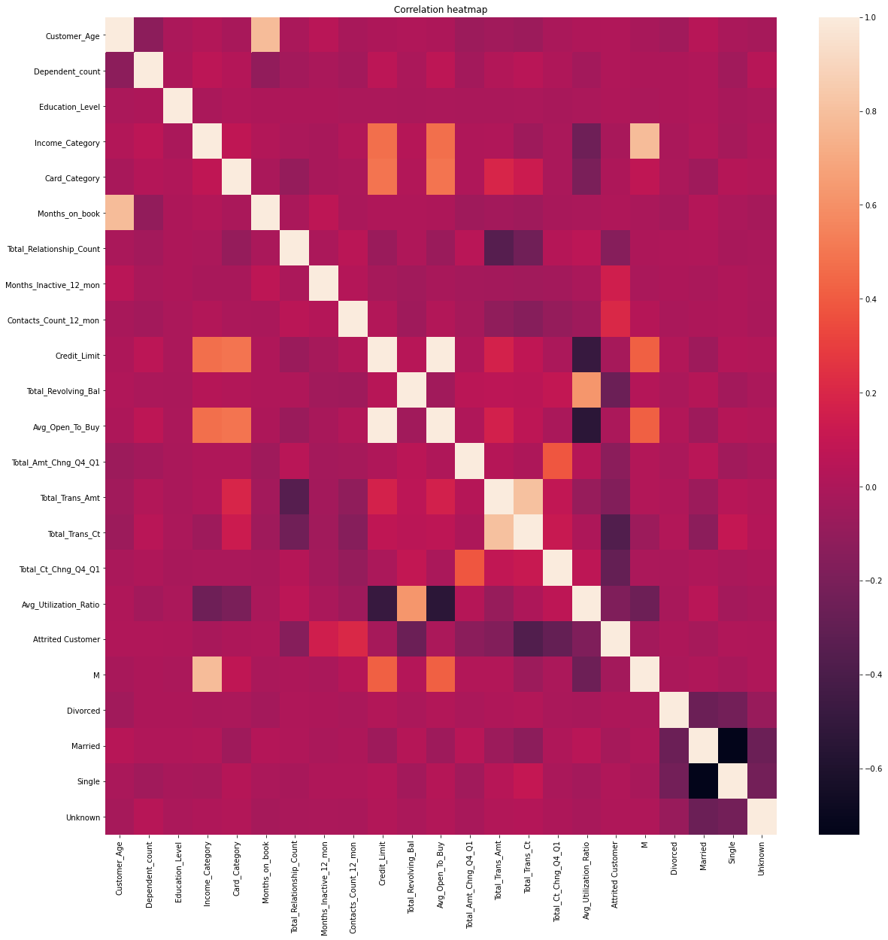
Image 16: Heatmap of correlation data.
Avg Open To Buy and Credit Limit, as well as Total Trans Amt and Total Trans Ct, have a significant association, as seen in Image 16. The Total Trans Amt, Total Relationship Ct, Avg Utilization Ratio, and Credit Limit all have an inverse relationship to one another.
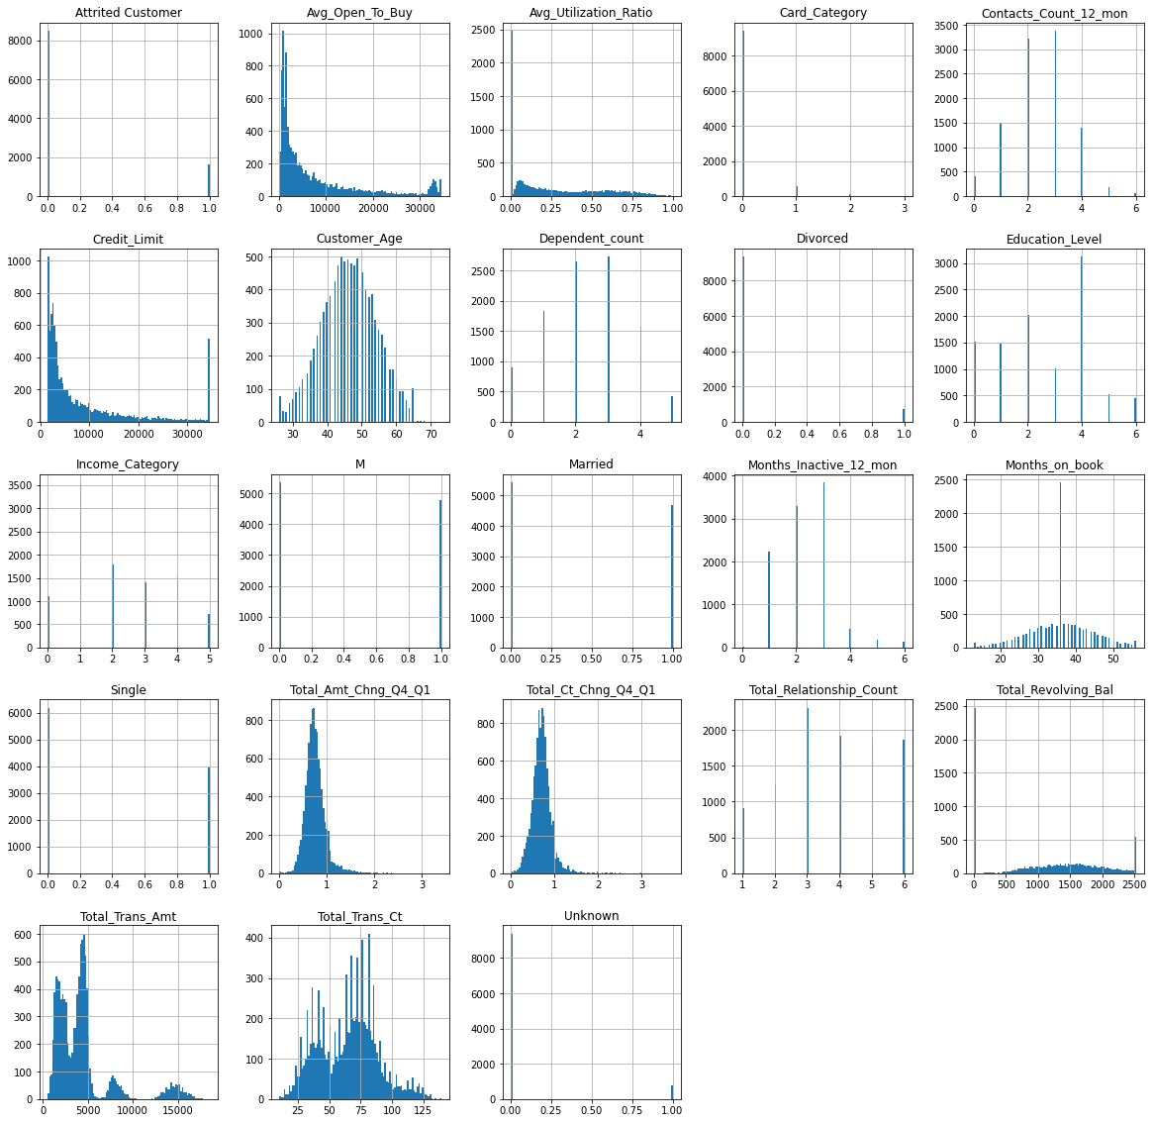
Image 17: Feature data histograms.
Image 17 demonstrated the left-skewed distributions of the Avg Open To Buy, Credit Limit, Total Amount, and Count Change; age has a unimodal distribution; and the left-skewed multimodal and bimodal distributions of the Total Transaction Amount and Total Transaction Count, respectively. Instead of a single histogram, the binary encoding of Marital Status produced distinct histograms for each variable. The data is sufficiently dense to be utilised by the ML model.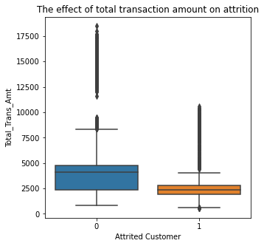 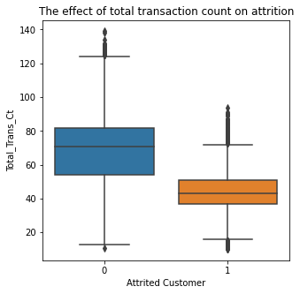 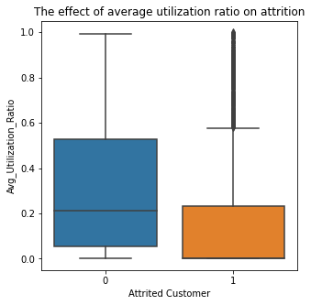
Image 18: Box plots to identify correlations..
Image 18 demonstrates a consistent pattern of client attrition for clients with average utilisation ratios, low transaction counts and amounts, indicating that these characteristics are critical to the model's success.
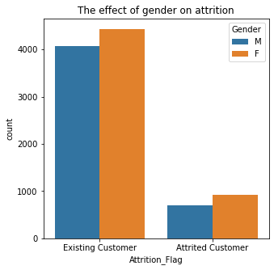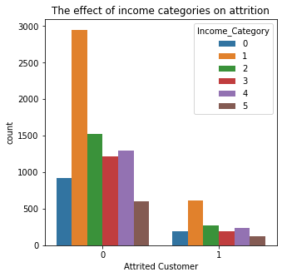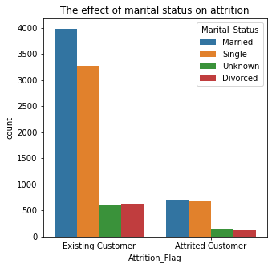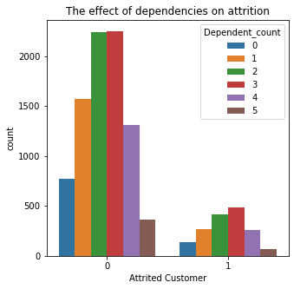
Image 19: Bar Chart identifying correlations.
Image 19's bar charts for marital status and gender reveal no trends in attrition, but the bar chart for income category indicates that clients making less than $40K annually are more likely to leave the company. Last but not least, the dependant count bar chart reveals that customers with three or fewer children are most at risk of attrition.

4.8. Feature selection.
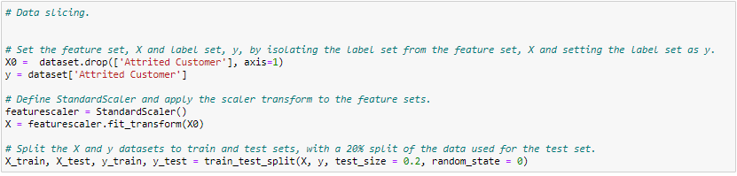
Image 20: Feature selection.
Image 20 demonstrates:
- The ".drop" method was used to separate the label data from the feature data. It was decided to call the final dataframe "X0".
- The label set was retrieved using the "df" function. The definition of the label data was "y."
- To normalise the feature set for usage in machine learning techniques, the "StandardScaler" function was defined as "featurescaler" and deployed to the feature set "X0" using the "fit.transform" function. The data was defined as X
- The feature set, label set, test set size, and pseudo random state were all sliced using the "train test split" function to guarantee the same outcome on each run.
The script was executed without errors.

4.9. K means clustering.
The data did not require a train test split and was converted to an array for use in the model.
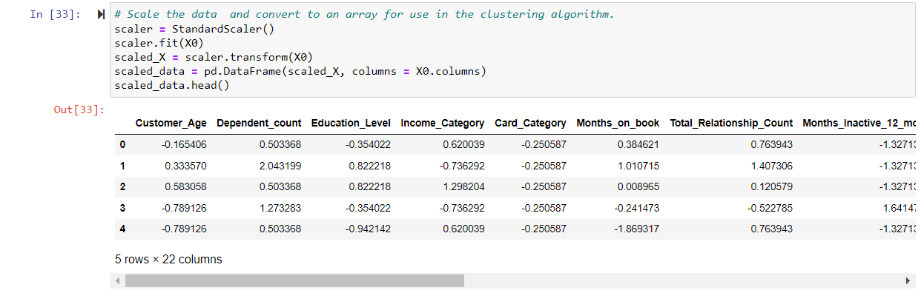
Image 21: Feature extraction

Image
The data was saved as a .csv file.
Image 22: Saving the extracted data.

The model aimed to test 1 to 10 clusters on the feature data due to incompatibility issues the model failed to execute. The error was shown in Image 28.
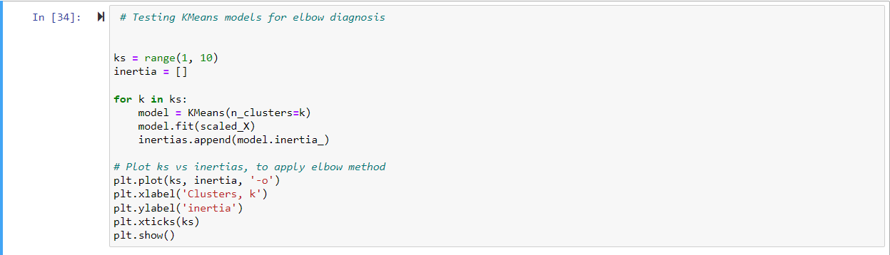
Image 23: Model consideration.

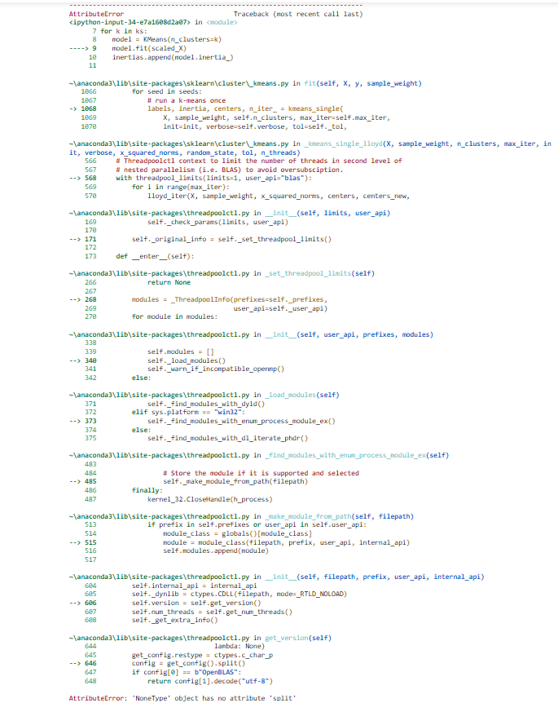
Image 24: Model compatibility error.

If functional, a plot would be generated to visualise the elbow. The taper of the elbow would be chosen as the number of KMeans clusters. The clusters and highlight the points of inertia within the clusters. For evaluation, the clusters would be compared to the label data to identify the accuracy of the model.

4.10 Random Forest.

Performance evaluation and model fitting.
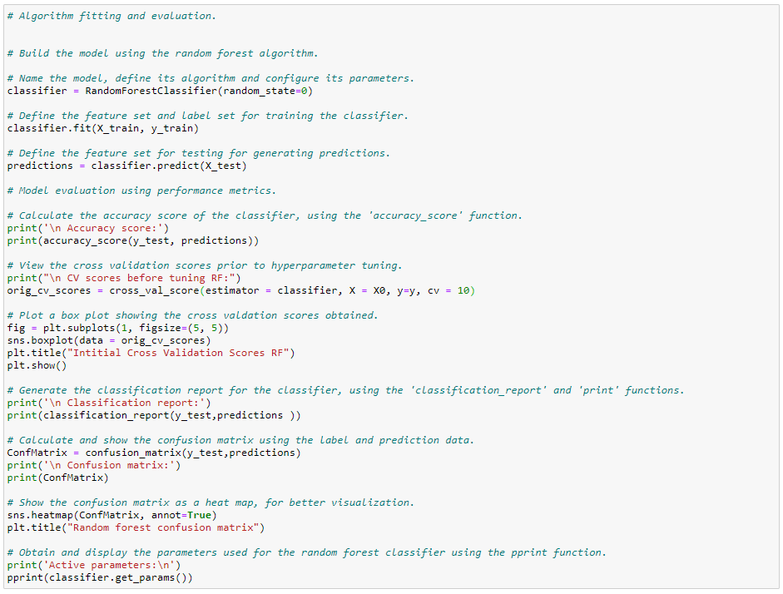
Image 25.1: Model fitting and scoring.
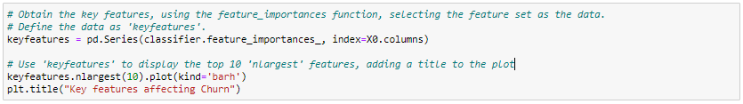
Image 25.2: Identification of key features.
It was displayed by Image 25.1 that:
To ensure consistency, the "RandomForestClassifier" method was used, with the pseudo random state specified as the single custom parameter. It was defined as "classifier."
To create predictions, which were then saved as "predictions," the ".fit" function was executed using the split training data.
To calculate each measure, the Scikit-learn "accuracy score", "classification report", and "confusion matrix" functions compared the predicted data against the test data. The "pprint" function was used to define and remember each function.
- Tenfold cross validation was done on the basic model using the "cross val score" function. Results were depicted in a box plot and designated as "orig_cv_scores."
For easier display, the confusion matrix was rendered as a heat map with comments using the ".heatmap" function. The Matplotlib ".title" function was used to set the title.
Image 25.2 depicts:
- A series of key features were created using the ".feature importances_" function, with the index set to the columns of the feature data, which were saved using the ".series" function and defined as "keyfeatures."
- A horizontal bar chart with the top 10 features was created using Matplotlib's ".plot" function and the ".nlargest" function. Using Matplotlib's ".title" function, the name of the plot was defined.
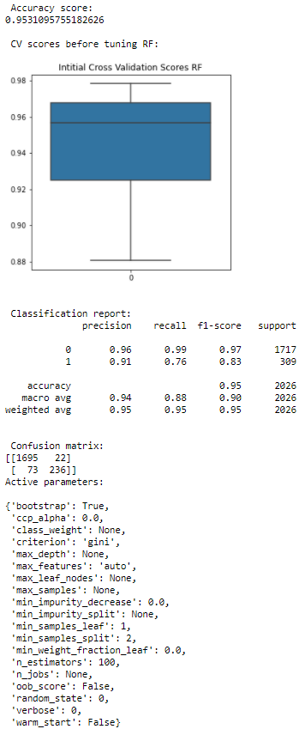
Image 26: Initial RF model scores and cross validation plot.
Image 26 demonstrates that the script was run flawlessly. With a 95.31% accuracy rate, the classifier predicted 1931 true outcomes (1695 true positive + 236 true negative) and 95 false outcomes (22 false positive + 73 false negative). A high score and a modest variance are displayed in the box plot.
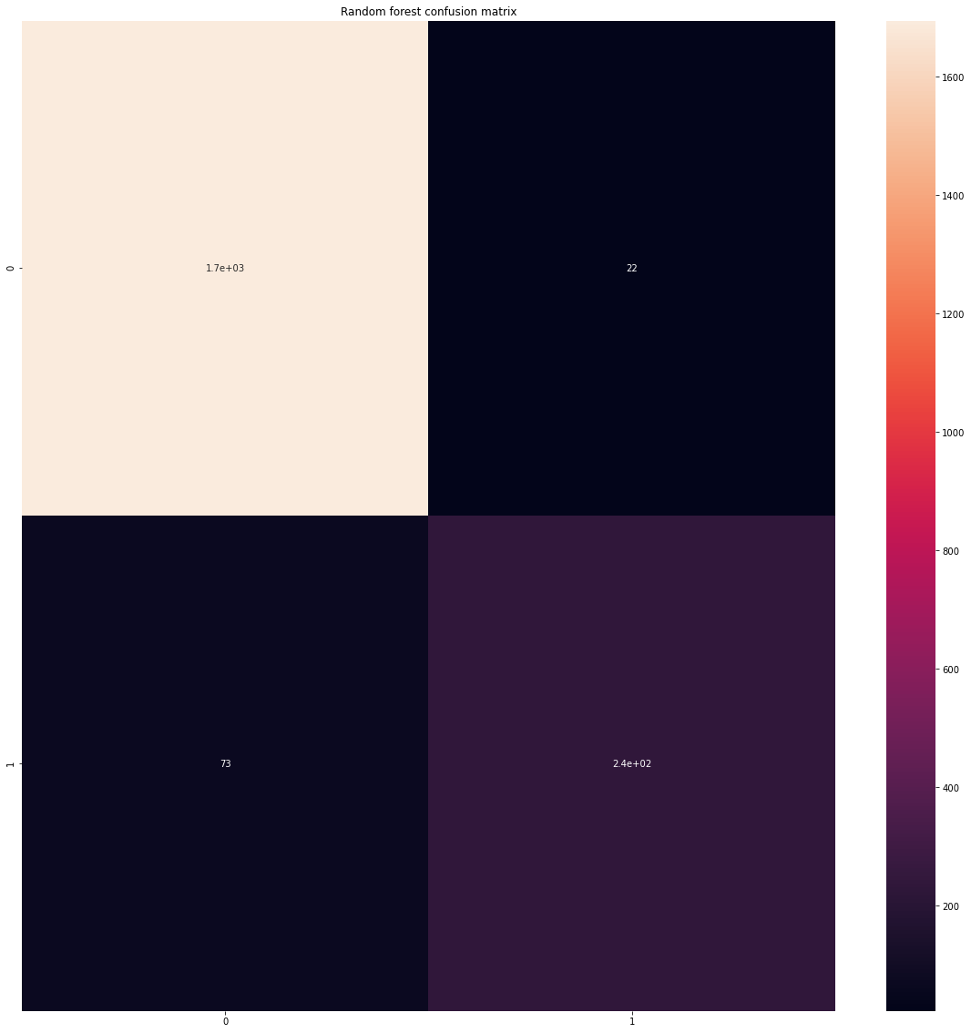
Image 27: Initial RF Confusion matrix.
Image 27 demonstrates most forecasts were true, as intended.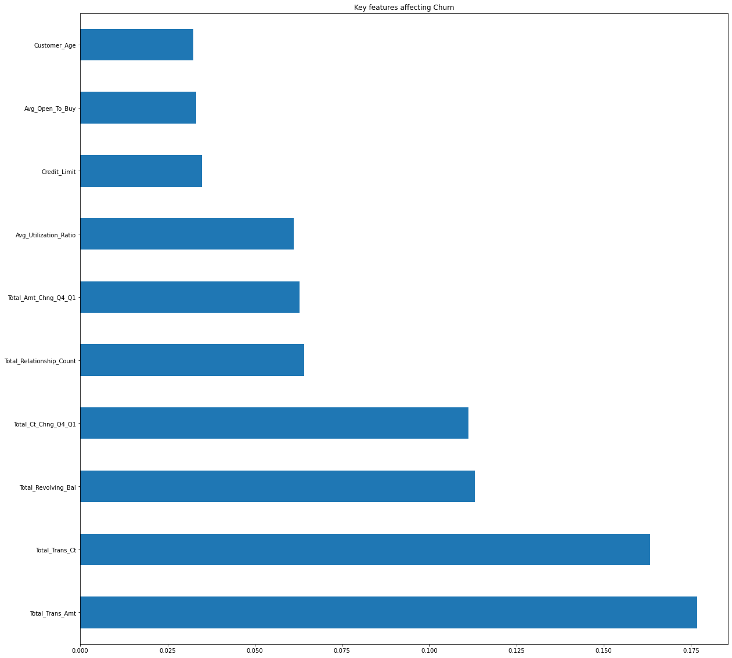
Image 28: Key features plot.
The main factors to influence attrition were discovered, as shown in Image 28.

Tuning of hyperparameters.
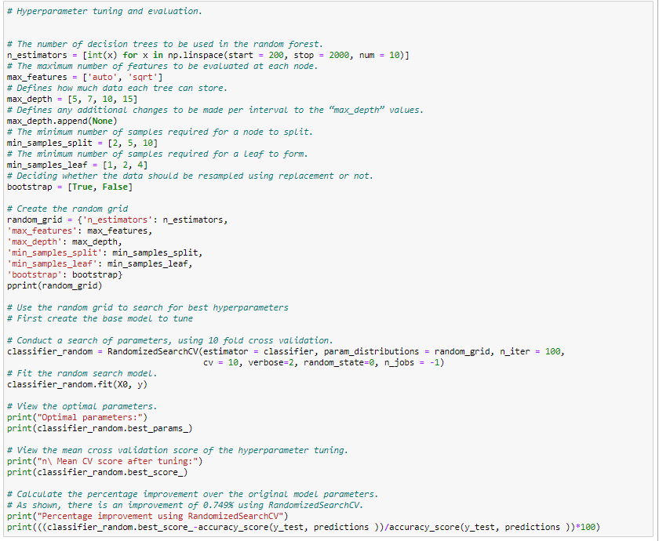
Image 29: Tuning of hyperparameters and validation.
The settings below were tweaked, as seen in Image 29:
- n estimators - Overfitting might result from a number that is too little or too big.
- Using the "np.linspace" function, 10 equally spaced values among both 200 and 2000 were chosen.
- max features - Underfitting might result from a number that is too big, and vice versa.
- max_depth –Trees with a high depth can be faster to compute but show underfitting, vice versa. Low depth values were considered, for optimal accuracy.
- The settings below were tweaked, as seen in Image 29 (Géron, 2019).
- n estimators - Overfitting might result from a number that is too little or too big.
- Using the "np.linspace" function, 10 equally spaced values among both 200 and 2000 were chosen.
- max features - Underfitting might result from a number that is too big, and vice versa. The feature types set will change the feature weights to identify the best settings.
- max depth -Trees with a high depth may compute more quickly, but they may also exhibit underfitting. Low depth values were considered for the best accuracy.
- max depth.append - Provides the possibility for precise parametrization. Unused. Setting a high number for min samples split might lead to inadequate nodes, which would cause underfitting, and vice versa. For evaluation, a small, medium, and big split were used.
- min_samples_leaf – Setting the minimum value for the result of a node split. Setting a high value can prevent the model from executing, while setting a low value can result in underfitting. Three small values were evaluated.
- The bootstrap was conImaged to be "true."
Following the configuration:
- A grid was built and named random grid to identify the parameters used in the randomised search.
- • When invoked, the "pprint" function was conImaged to read the "random grid" file and decipher the selected configuration.
- In the "RandomizedSearchCV" function, the estimator was set to the random forest model, the parameter distributions to the "random grid"; the cross validation to perform 10 folds, the verbose state to only display important messages; the pseudo random state used a different seed to vary the data; The n jobs were defined as -1 to use all processing power.
- Prior to slicing, the random search model was fitted to the data. The model was named "classifier random."
- The ideal parameters, mean cross validation score, and % accuracy increase of the hyperparameter adjustment were output in a string using the "print" function.
- Scikit-learn’s ".best params_" and ".best score_" methods were used with the random classifier model and the "print" function presented the results.
- To measure the progress, an equation was developed to determine the new score's percentage difference from the baseline.
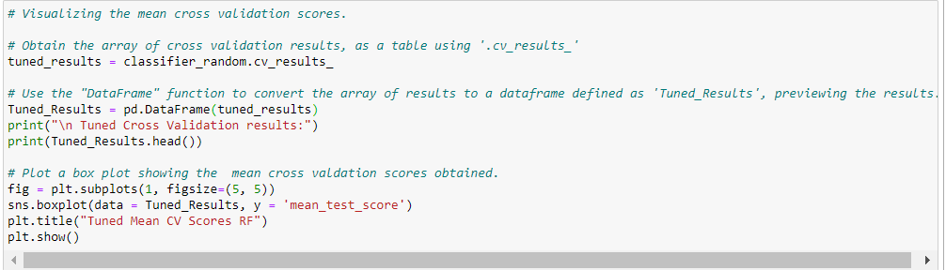
Image 30: Visualising Mean CV scores.
The mean CV results are shown in Image 30 in the following manner:
- The ".cv results_" function was used with the data parameter set to "classifier random". The findings were named "tuned results".
- The data frame was previewed using the 'head' function.
- A data frame was created from the results using the "Dataframe" function.
- A box plot was created using the "_test score" column to display the data.
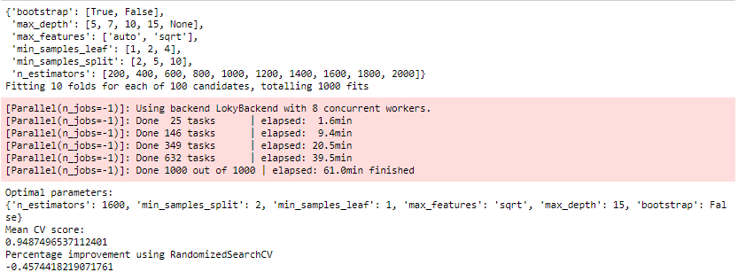
Image 31: Tuned RF Mean CV score and percentage improvement.
Image 31 illustrates how the script was completed flawlessly. With the parameters shown above, the Randomized Search Cross Validation method reduced the initial accuracy by 0.45% during a 61-minute runtime.
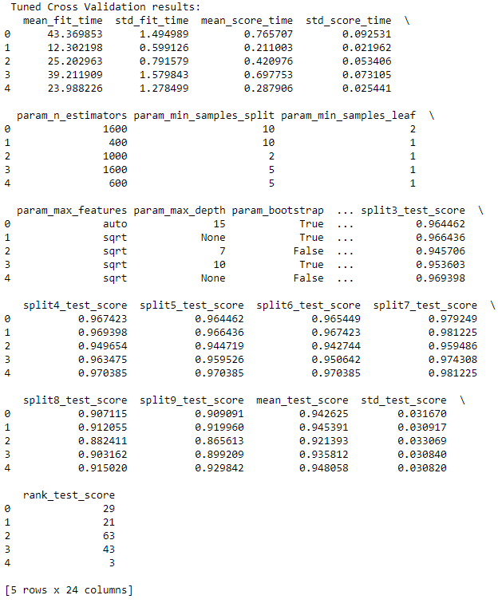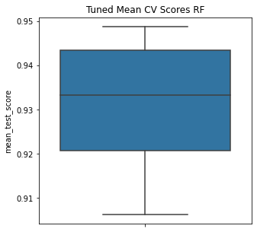
Image 32.1: Tuned RF Cross validation results. Image 32.2: Tuned RF Cross validation plot.
The cross-validation data were collected in table format, and Image 32 displays the mean cross-validation scores. The box plot displayed lower scores and a bigger variance than the original model.

4.11. Decision Tree

Performance evaluation and model fitting.

Image 33: Model selection.
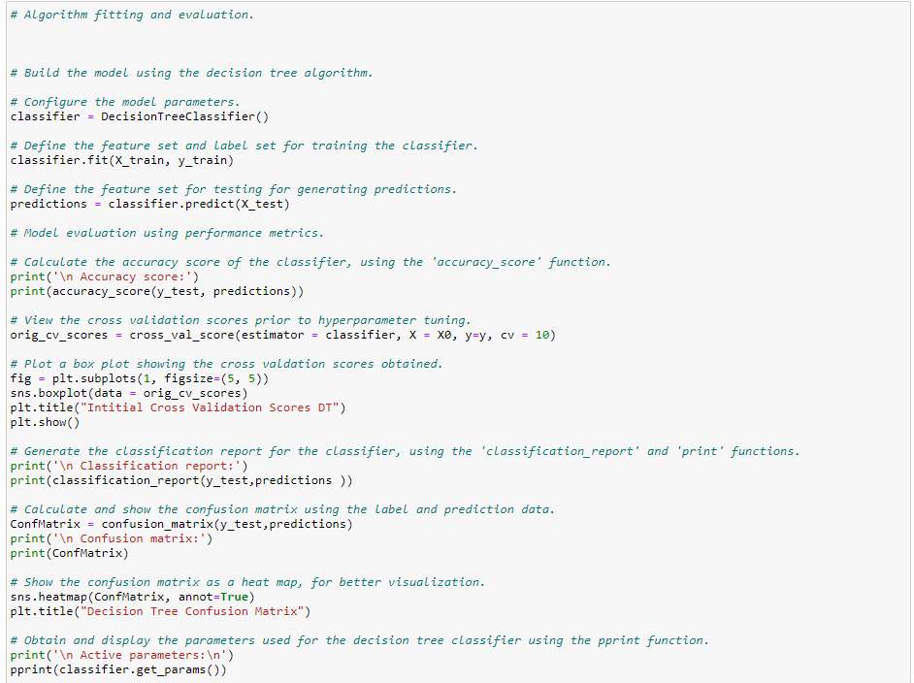

Image 34: Model configuration.
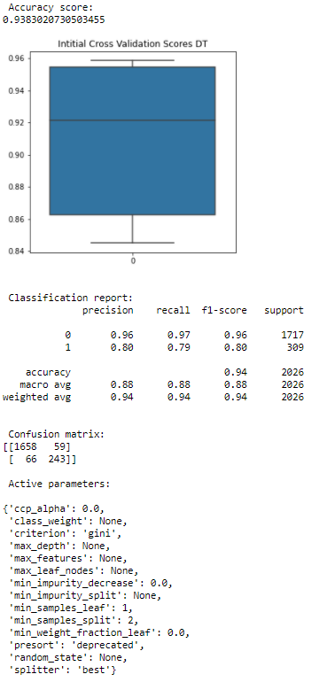
Image 35: Initial DT Cross validation score and other metrics.
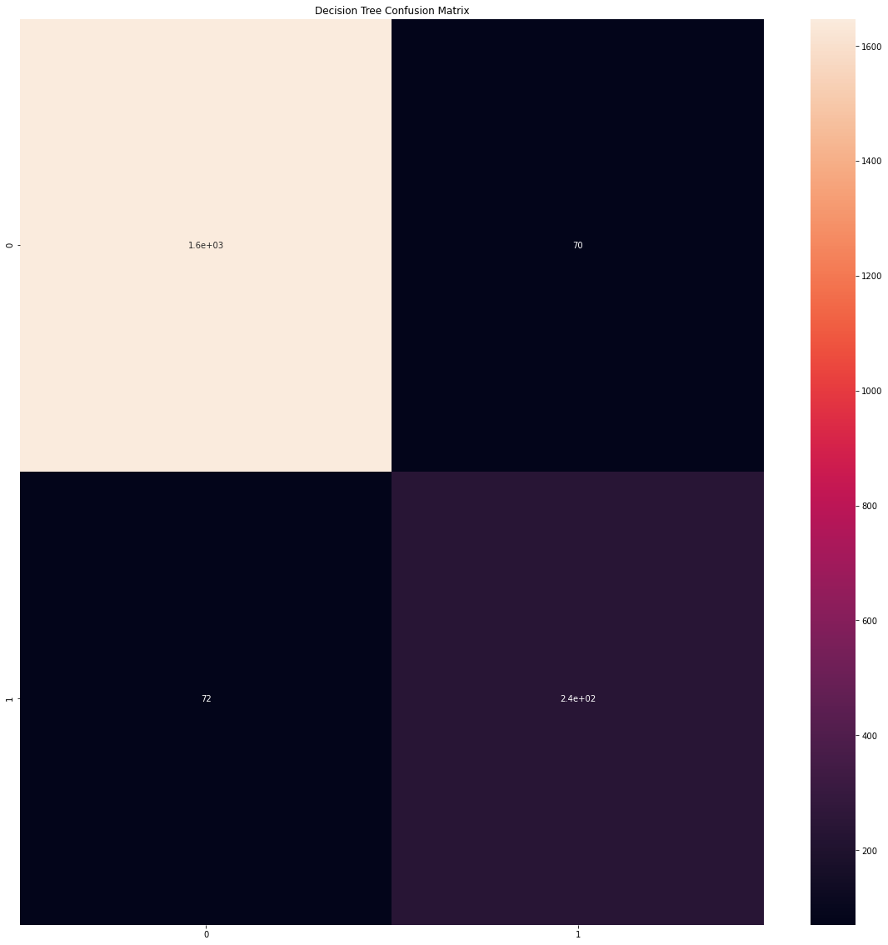
Image 36: Initial DT Confusion matrix.

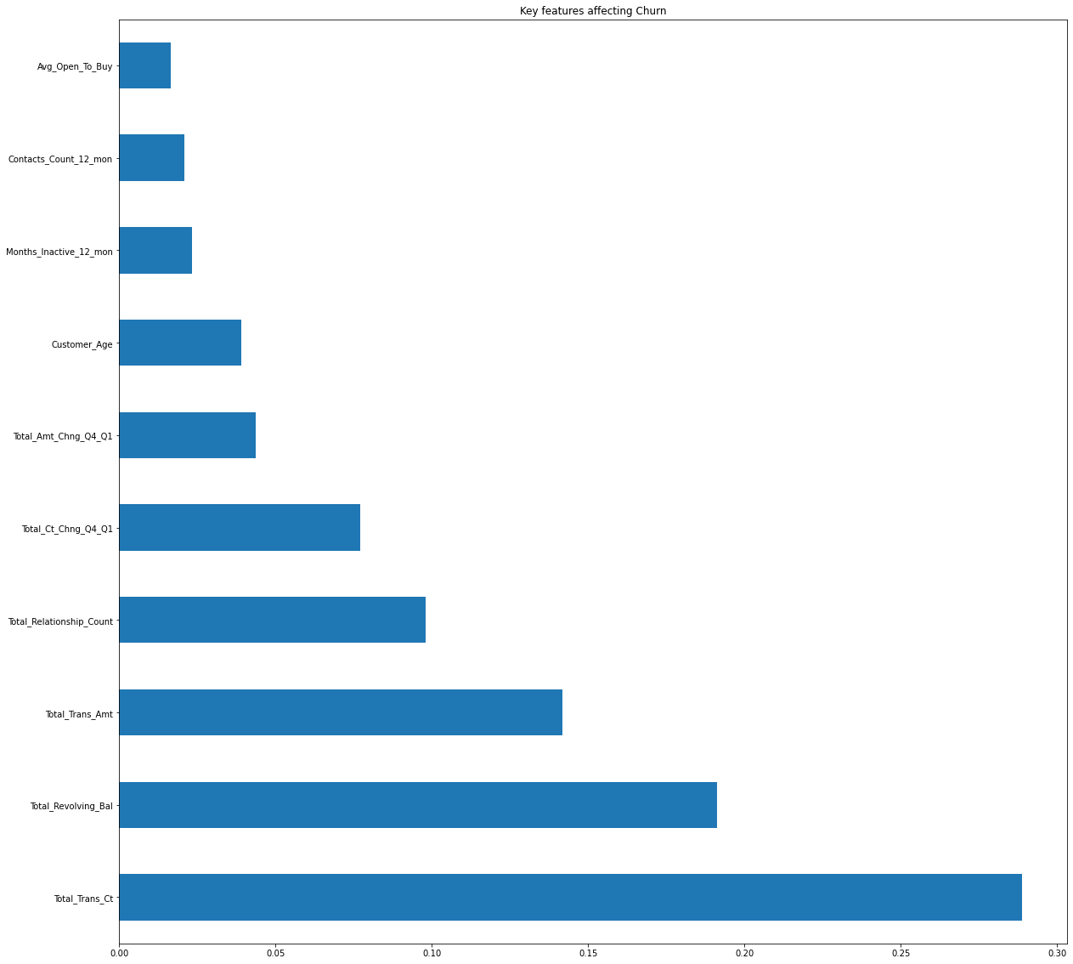
Image 37: Key feature extraction.
Another method was used to compare to the current model, as seen in Images 33 and 34. The same data was applied to the imported decision tree classifier in order to derive its performance measures, displayed in Image 35.
Images 35-37 demonstrate that the precision for a true positive is 12% lower than the random forest model, while the accuracy score is approximately 3% lower than the random forest model. The randomised search is most likely to blame for the wide variance in cross-validation scores that is shown in the box plot. The random forest model's key feature data differs from the decision tree, as a result of the model's design.

Tuning of hyperparameters.

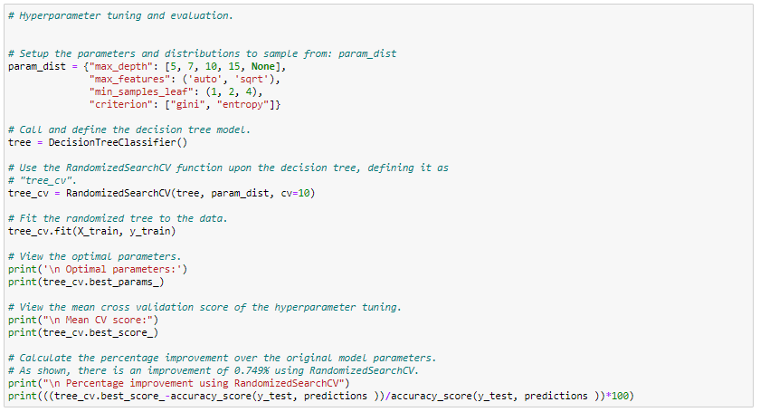
Image 38: Tuning of hyperparameters
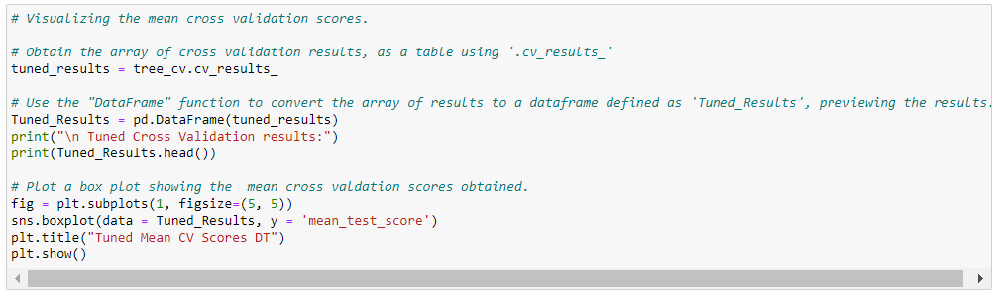
Image 39: Cross Validation configuration.
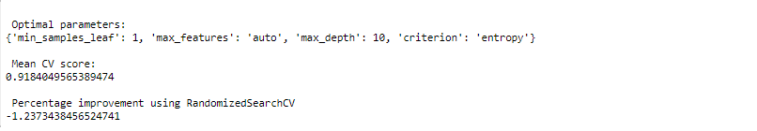
Image 40: Tuned DT Mean CV score and percentage improvement.

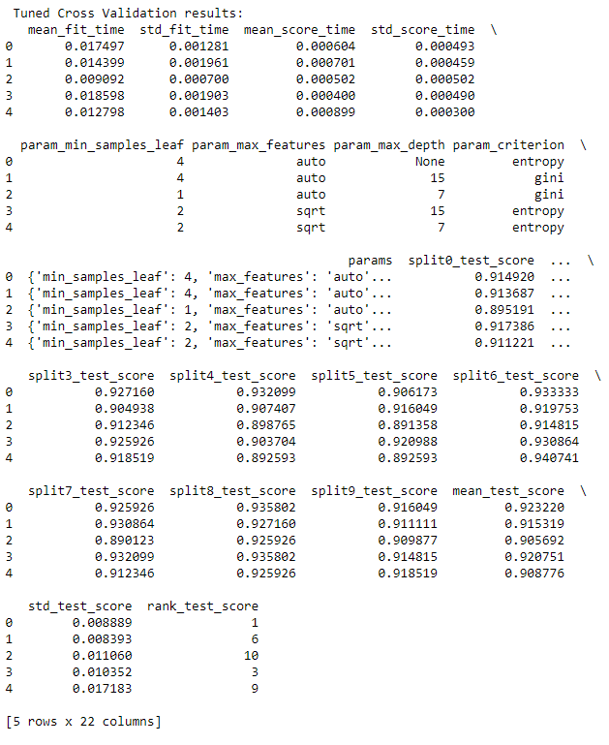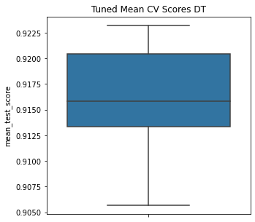
Image 41.1: Tuned DT Cross Validation Results Image 41.2: Tuned Mean Cross Validation score plot.
The methods of parameter tuning and acquiring cross-validation scores were shown in Images 38 and 39.
Image 40 demonstrates that RandomizedSearchCV reduced the model's accuracy by 1.32%, most likely as a result of selecting the wrong search parameters.
The cross-validation data was collected in table format, and Image 41 displays the mean cross-validation scores.

4.12. Findings and Discussion
For models that favour an equally balanced dataset for training, the data imbalance in Image 15 was not optimal.
Image 26 shows that the Random Forest model had excellent results with accuracy scores of 95.31%, precision scores of 91%, and recall scores of 76%. Image 27 illustrates the tuned model, which has a mean CV score of 96.38% and exhibits an improvement of 1.12% compared to the initial model. Image 31 illustrates the decision tree model's performance, which was poorer. It scored an accuracy of 93.14%, a precision score of 79%, and a recall score that was the same as the original model.
Total transaction amount, total transaction count, and total revolving balance were the top 3 crucial factors for prediction. These high-value customers, who were determined to be most at danger of leaving, should be the bank's primary emphasis.
For both models, the CV results were displayed in Images 26, 32.2, 35, and 41.2, respectively.
Prior to tuning:
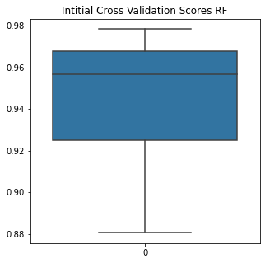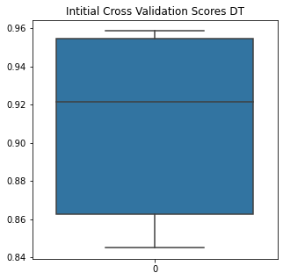
Post tuning:

As a result of the tuning, both models showed a reduced interquartile range hence a greater accuracy than prior to tuning. The random forest showed a greater accuracy overall.

5. Conclusion, Recommendations and Future Work

Conclusion.
In conclusion, it was discovered that the random forest method is a helpful tool for producing predictions for datasets with numerous attributes.

Recommendations.
The bank should concentrate on keeping regular customers who frequently do sizable transactions, since they were discovered to be at the biggest risk of leaving.

Future work.
Datasets on bank churn will always be unbalanced. The SMOTE method will be used in the future to address this problem. Instead of replicating existing rows, the data is utilised to create synthetic data with identical qualities using the oversampling approach (Brownlee, 2016).
A certain order of functions must be used for each phase of the procedure. In order to provide a reusable and user-friendly interface, groups of functions will eventually be specified as classes and called to the notebook from their modules.
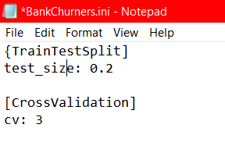
Image 42: JSON type configuration file.
A JSON configuration file will also be added to the script. It enables remote parameter control without changing the main script, as seen in Image 42.

6. References
ACM, 2011. Model Selection Strategy for Customer Attrition Risk Prediction in Retail Banking. [ebook] Fan Li et al. Available at: <https://dl.acm.org/doi/pdf/10.5555/2483628.2483643> [Accessed 21 August 2022].
Brownlee J. SMOTE for Imbalanced Classification with Python [Internet]. Machine Learning Mastery. 2016 [cited 21 August 2022]. Available from: https://machinelearningmastery.com/smote-oversampling-for-imbalanced-classification/
Géron, A., 2019. HANDS-ON MACHINE LEARNING WITH SCIKIT-LEARN, KERAS, AND TENSORFLOW: CONCEPTS, TOOLS, AND TECHNIQUES. 2nd ed. Sebastopol: O'REILLY MEDIA.
HBS, 2013. Managing churn to maximize profits. [ebook] Aurélie Lemmens & Sunil Gupta. Available at: <https://www.hbs.edu/faculty/Publication%20Files/14-020_2d6c9da0-94d3-4dd5-9952-d81feb432f61.pdf> [Accessed 21 August 2022].
IJCOTJournal, 2016. Data Mining as a Tool to Predict Churn Behavior of Customers. [ebook] Vivek Bhambri. Available at: <http://www.ijcotjournal.org/volume-2/issue-3/IJCOT-V2I3P307.pdf > [Accessed 21 August 2022].
Kaggle, 2020. Credit Card customers. [online] Sakshi Goyal, Available at: <https://www.kaggle.com/sakshigoyal7/credit-card-customers> [Accessed 21 August 2022].
Matplotlib [Internet]. Matplotlib.org. 2022 [cited 21 August 2022]. Available from: https://matplotlib.org/
NumPy [Internet]. Numpy.org. 2022 [cited 21 August 2022]. Available from: https://numpy.org/
pandas [Internet]. Pandas.pydata.org. 2022 [cited 21 August 2022]. Available from: https://pandas.pydata.org/
Retention Idea. 2022. How Banks and Financial Institutions Use Customer Retention Strategies Effectively. [online] Available at: <https://www.retentionidea.com/customer-retention-strategies-employed-banks-financial-institutions#:~:text=Customer%20retention%20strategies%20are%20essential,retention%20strategies%20report%20better%20ROI> [Accessed 21 August 2022].
Seaborn [Internet]. Seaborn.pydata.org. 2022 [cited 21 August 2022]. Available from: https://seaborn.pydata.org/
scikit-learn [Internet]. Scikit-learn.org. 2022 [cited 21 August 2022]. Available from: https://scikit-learn.org/stable/

